***Computer Networks LAB 3***

## QUESTION NO. 1:

## HTTP, TCP, SNMP, DNS

## 

## QUESTION N0. 2:

## 

Time =**0.024143000 seconds**

QUESTION NO. 3:

The 2nd GET request was not successful because it gave response with an error c**ode 404 (not found).**

Question no4:

**Version 1.1**

Question No. 5:

***Accept-Language: en-us, en;q=0.50\r\n***

Question no 6:

**Computer: 192.168.1.102  
gaia.cs.umass.edu: 128.119.245.12**

**Question no 7:**

**computer: 00:08:74:4f:36:23  
gaia.cs.umass.edu: 00:06:25:da:af:73**

**Question no 8:**

**sending port: 4127  
receiving port: 80  
port 80 represents the port of host server (gaia.cs.umass.edu)**

**Question no 9:**

**1st request status code: 200  
2nd request status code: 404**

**Question no 10:**

**Last-Modified: Tue, 23 Sep 2003 05:29:00 GMT\r\n**

**Question no 11:**

**1834 bytes**

***Trace 2***

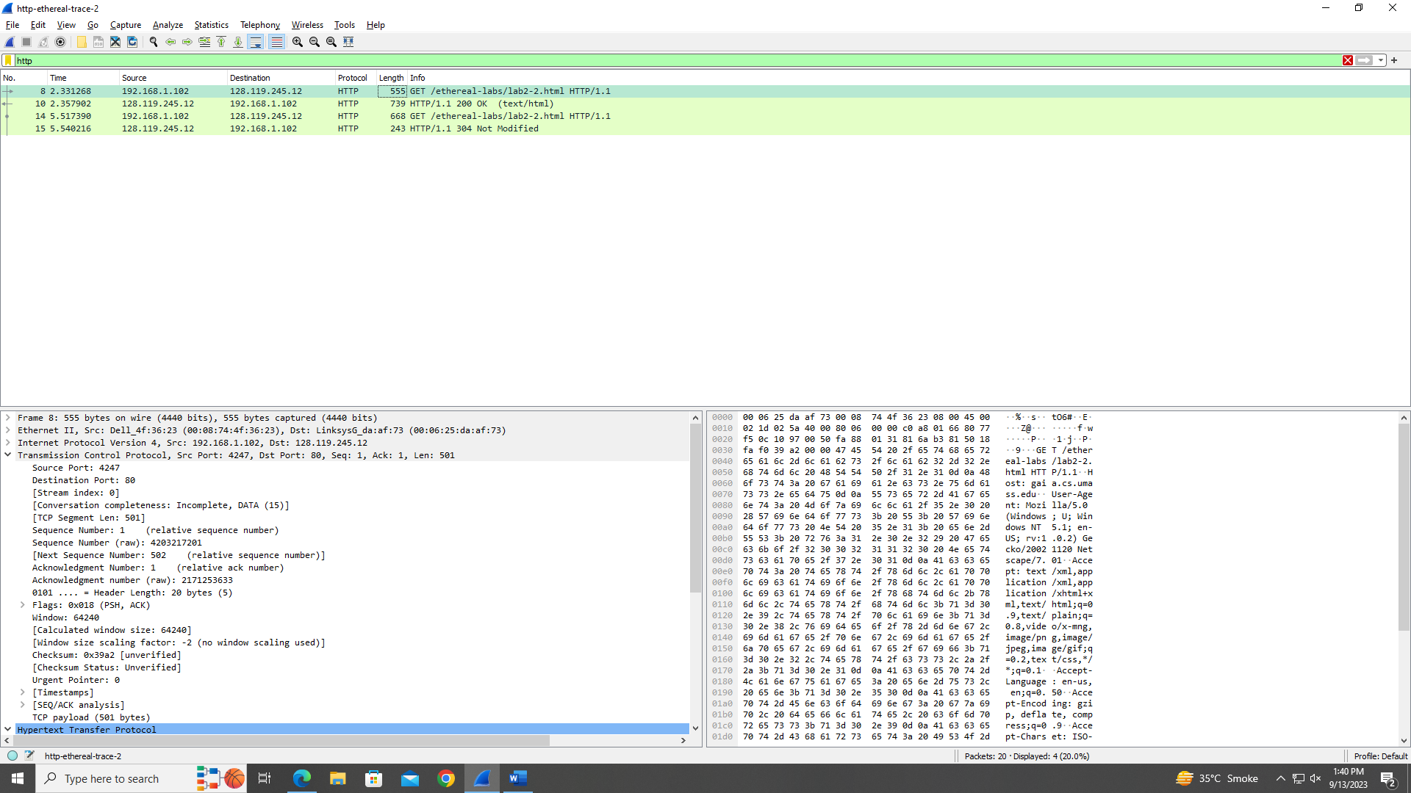

**Q1:**  
No. we didn’t see an “IF-MODIFIED-SINCE” line in the HTTP GET?

**Q2**:  
Yes, the contents of the file are returned explicitly.

**Q3:**  
the 2nd GET request contains “if-modified-since”, followed by the information of the header file.

**Q4:**  
304 (not modified). The server did not return the contents of the file explicitly because of the condition “if-modified-since”.

**http-ethereal-trace-3**

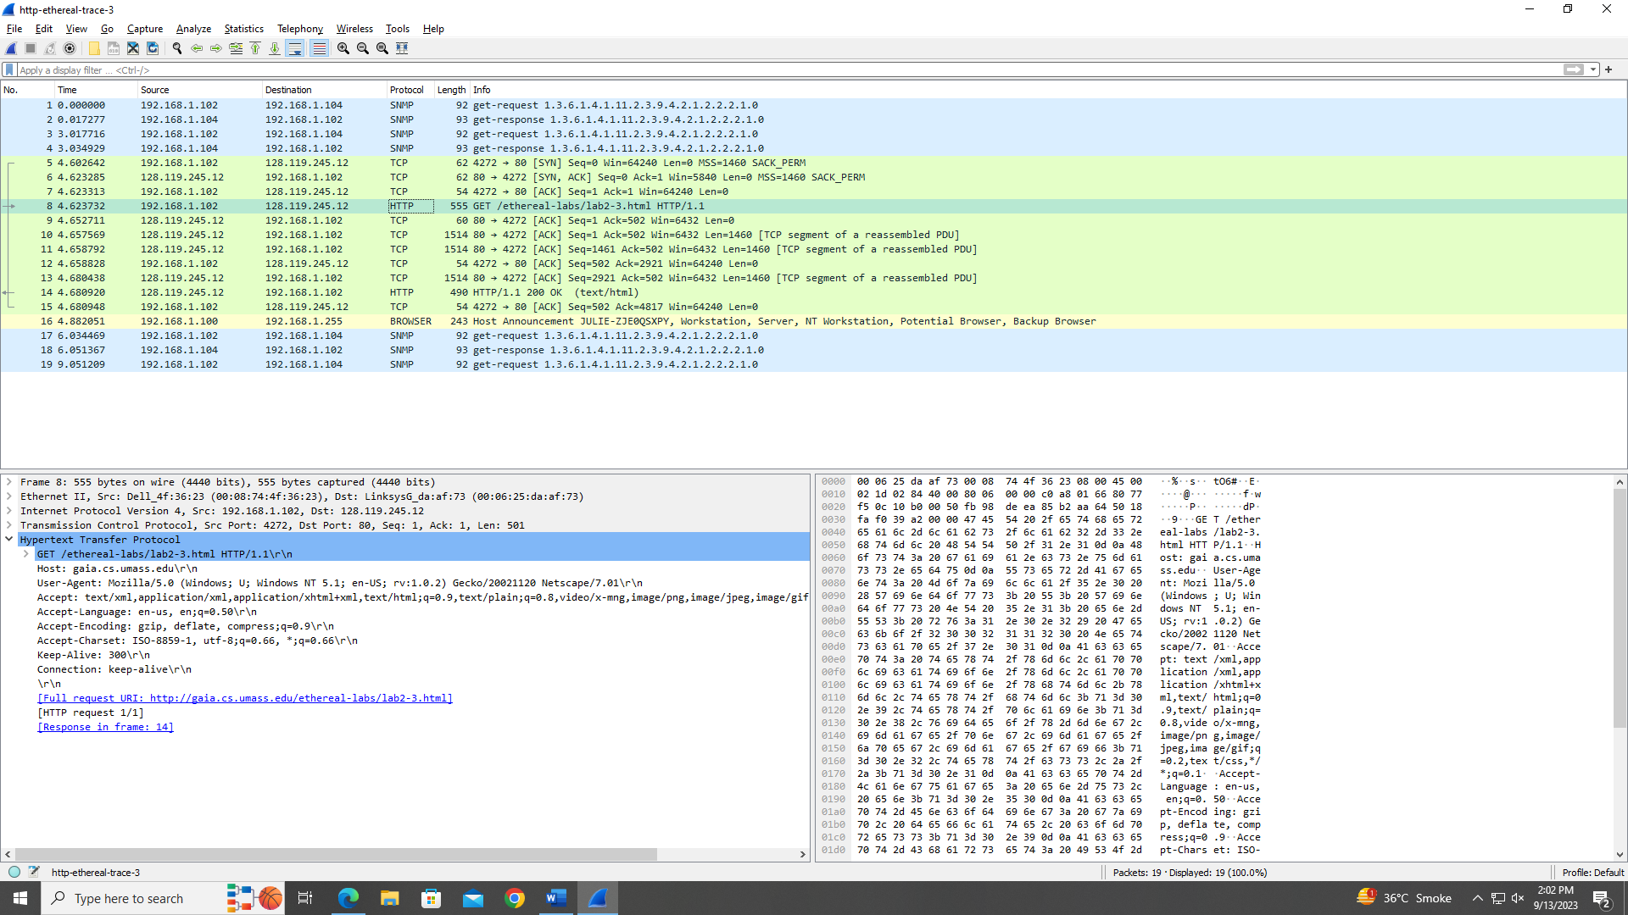

**Q5**:  
1

**Q6:**  
**packet no. 8**

**Q7:**  
**packet no. 14**

**Q8:**  
**200 (OK)**

**Q9:**  
5 TCP packets from packet no. 9 to 13